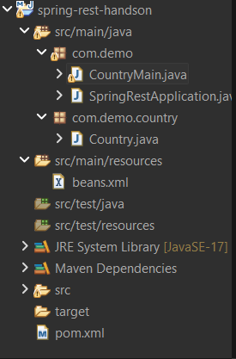

package com.demo;

import org.springframework.context.ApplicationContext;
import org.springframework.context.support.ClassPathXmlApplicationContext;

import com.demo.country.Country;

public class CountryMain {

public static void main(String[] args) {

ApplicationContext context =
new ClassPathXmlApplicationContext("beans.xml");

Country c = (Country) context.getBean("country");
c.show();
}
}

package com.demo;

import org.springframework.boot.SpringApplication;
import org.springframework.boot.autoconfigure.SpringBootApplication;

@SpringBootApplication
public class SpringRestApplication {

public static void main(String[] args) {
SpringApplication.run(SpringRestApplication.class, args);
}
}

package com.demo.country;

public class Country {

private String code;
private String name;

public void setCode(String code) {
this.code = code;
}

public void setName(String name) {
this.name = name;
}

public void show() {
System.out.println("Country Code: " + code);
System.out.println("Country Name: " + name);
}
}

<beans xmlns="http://www.springframework.org/schema/beans"
xmlns:xsi="http://www.w3.org/2001/XMLSchema-instance"
xsi:schemaLocation="
http://www.springframework.org/schema/beans
http://www.springframework.org/schema/beans/spring-beans.xsd">

<bean id="country" class="com.demo.country.Country">

<property name="code" value="IN"/>
<property name="name" value="India"/>

</bean>

</beans>

<project xmlns="http://maven.apache.org/POM/4.0.0"
xmlns:xsi="http://www.w3.org/2001/XMLSchema-instance"
xsi:schemaLocation="http://maven.apache.org/POM/4.0.0 https://maven.apache.org/xsd/maven-4.0.0.xsd">

<modelVersion>4.0.0</modelVersion>

<parent>
<groupId>org.springframework.boot</groupId>
<artifactId>spring-boot-starter-parent</artifactId>
<version>3.2.0</version>
</parent>

<groupId>com.demo</groupId>
<artifactId>spring-rest-handson</artifactId>
<version>0.0.1-SNAPSHOT</version>

<properties>
<java.version>17</java.version>
</properties>

<dependencies>

<!-- Spring Boot Web -->
<dependency>
<groupId>org.springframework.boot</groupId>
<artifactId>spring-boot-starter-web</artifactId>
</dependency>

</dependencies>

</project>

